**EXPERIMENT – 3**

**AIM: -** To study the Packet tracer tool Installation and User Interface Overview

**To understand environment of CISCO PACKET TRACER to design simple network.**

**USER INTERFACE OVERVIEW:** 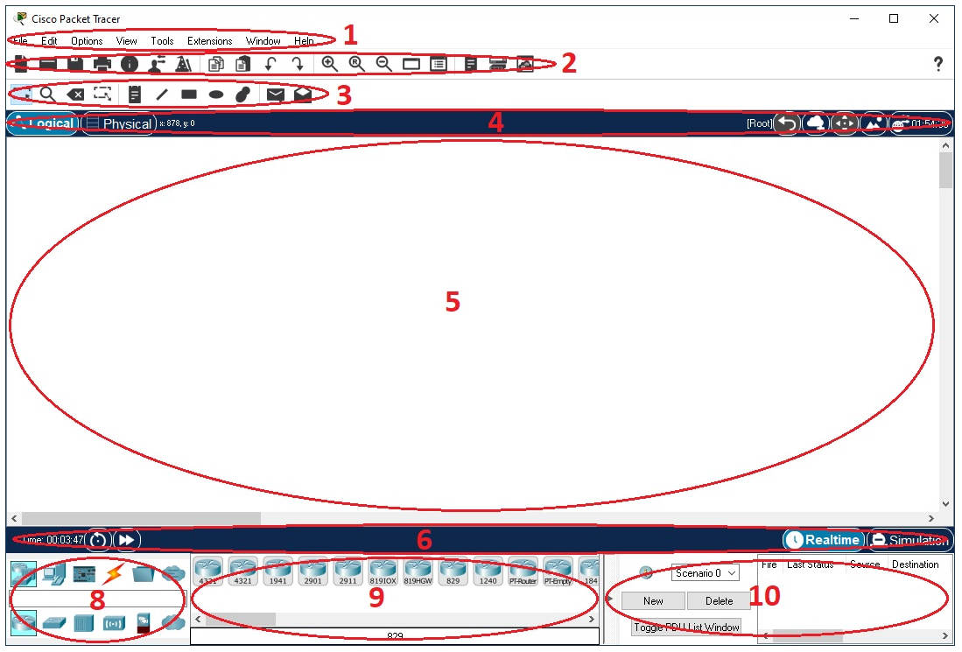

The layout of Packet Tracer is divided into several components. The components of the Packet Tracer interface are as follows:

**1. Menu bar** – This is a common menu found in all software applications; it is used to open,

save, print, change preferences, and so on.

**2. Main toolbar** – This bar provides shortcut icons to menu options that are commonly

accessed, such as open, save, zoom, undo, and redo, and on the right-hand side is an icon

for entering network information for the current network.

**3. Common tools bar** – This toolbar provides controls for manipulating topologies, such as

select, move layout, place note, delete, inspect, resize shape, and add simple/complex PDU.

**4. Logical/Physical workspace tabs** – These tabs allow you to toggle between the Logical and Physical work areas.

**5. Workspace** – This is the area where topologies are created and simulations are displayed.

**6. Real-time/Simulation tabs** – These tabs are used to toggle between the real and simulation modes. Buttons are also provided to control the time, and to capture the packets.

**7. Network component box** – This component contains all of the network and end devices

available with Packet Tracer, and is further divided into two areas:

**8**. **Device-type selection box** – This area contains device categories

**9**. **Device-specific selection box** – When a device category is selected, this selection box displays the different device models within that category

**10. User-created packet box** – Users can create highly-customized packets to test them

topology from this area, and the results are displayed as a list.

**Analyse the behaviour of network devices using CISCO PACKET TRACER simulator.**

a. 4 Generic PCs and One HUB:

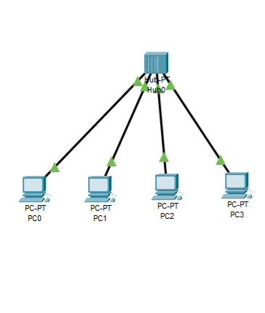 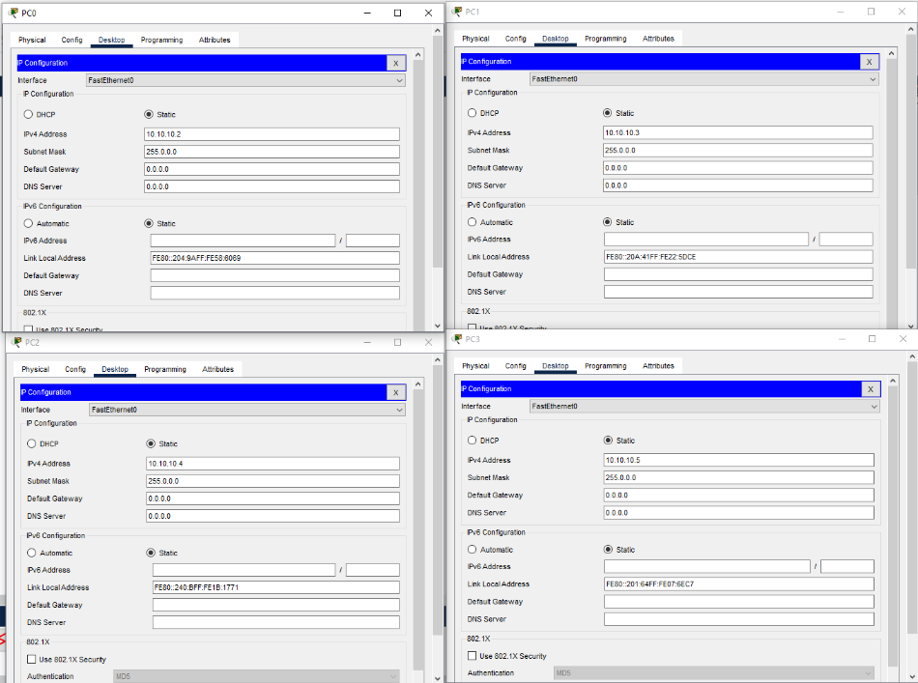

b. 4 Generic PCs and One Switch:

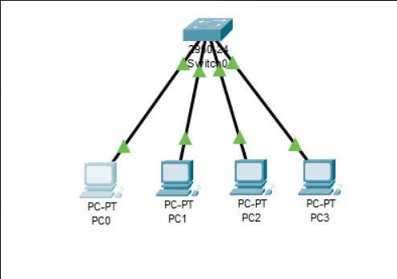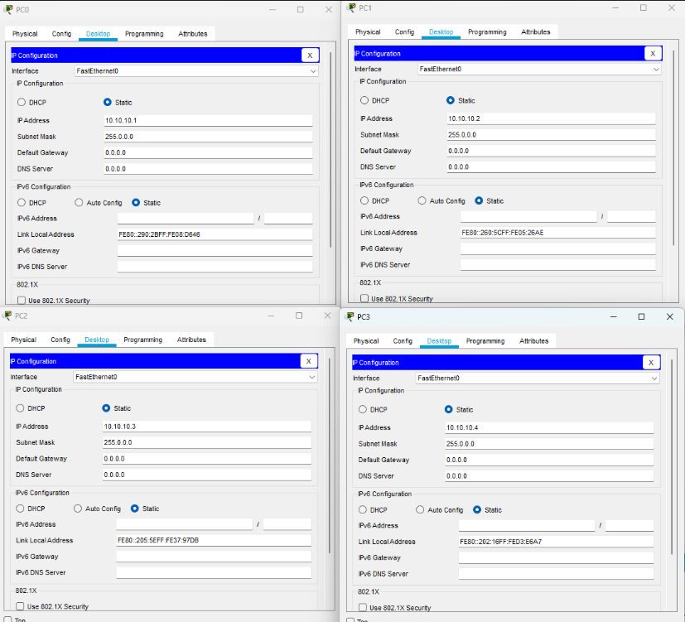

**RESULT: -**

Cisco packet have been installed successfully and the interface is studied.